Milestone 3 System and software requirements

WinWin

Ride-hailing platform for local-motorcycle service provider and user

Present to

Dr. Pittipol Kantavat and Dr. Ronnakorn Vaiyavuth

By G14 Waterfall

6230123921 Thitaree Setwipattanachai

6230252121 Tarm Kalavantavanich

6231301421 Kanokpich Chaiyawan

6231304321 Kittipong Deevee

6231307221 Jirawat Kusalangkurwat

6231333521 Nopdanai Sayamnet

6231353021 Raviporn Akekunanon

6231372021 Atiwat Deepo

Analysis phase document

2110335 Software Engineering I, Semester 1 of Academic year 2021

Department of Computer Engineering,

Faculty of Engineering, Chulalongkorn University

**Table of Contents**

Introduction 1

Objective of the analysis document 1

Details of requirements 2

Overview of the to-be (proposed) system context 10

Term definitions 11

List of stakeholders and their responsibilities 11

Proposed method of systems analysis 12

Business process modeling 13

Detail Essential Use Case diagram and description 15

Class diagrams and CRC Cards 21

Sequence diagram 26

Behavioral State Machine 28

Verifying and validating the analysis model 29

Verifying and validating functional model 29

Verifying and validating functional model 31

Verifying and validating behavioral model 34

Verifying and validating between models 35

Contributions 38

**List of figures**

Figure 1: The flow of to-be system 10

Figure 2: Activity diagram of “Make payment” Use case 13

Figure 3: Activity diagram of “Book a Ride” Use case 14

Figure 4: Use case diagram of WinWin System 15

Figure 5: Class diagram of WinWin System 21

Figure 6: CRC Card of Class “Customer” 23

Figure 7: CRC Card of Class “Rider” 24

Figure 8: CRC Card of Class “Manager” 25

Figure 9: Sequence diagram of “Book a Ride” Use case 26

Figure 10: Sequence diagram of “Make payment” Use case 27

Figure 11: Behavioral state machine of Class “Ride” 28

Figure 12: Validating of functional model of use case “Book a ride” 29

Figure 13: Validating of functional model of use case “Make payment” 30

Figure 14: Validating of structural model of class “Rider” 31

Figure 15: Validating of structural model of class “Customer” 32

Figure 16: Validating of structural model of class “Manager” 33

Figure 17: Validating of behavioral model of use case “Book a ride” and use case “Make payment” 34

Figure 18: Validating between functional model and structural model in use case “Make payment” 35

Figure 19: Validating between functional model and behavioral model of use case “Make payment” 36

Figure 20: Validating between functional model and behavioral model of use case “Book a ride” 37

**List of tables**

Table 1: Definitions 11

Table 2: Use case description of “Book a ride” 17

Table 3: Use case description of “Make payment” 18

Table 4: Use case description of “Initiate a ride” 20

Table 5: Contributions 38

Project name: WinWin

Ride-hailing platform for local-motorcycle service provider and user

# Introduction

Nowadays, motorcycle taxis are a major type of transportation in Bangkok (second only to MRT). However, riders have low income because ride-hailing platforms snatch their market share. Moreover, ride-hailing platforms can make users more satisfied than motorcycle taxis e.g., users can call ride-hailing platforms everywhere.

Therefore, WinWin wants to digitalize the motorcycle taxi system and to utilize route familiarity and locality of local motorcycle taxis to be an advantage that other ride-hailing platforms do not have.

WinWin, an online platform that connects customers with the local motorcycle taxis, has two business partners. Firstly, the Department of Land Transport, Ministry of Transport, which provides WinWin with the information about motorcycle taxis in the Bangkok area. Secondly, Winnonie, a startup founded by Bangchak Corporation group that rents out electric motorcycles.

WinWin believes that employing local motorcycle taxis as service providers is the best option since the riders are familiar with the route and can arrive at the customer's location faster than other riders from other ride-hailing platforms.

WinWin also thinks that building this application would satisfy stakeholders such as the Department of Land Transportation, Ministry of Transport, Winnonie, Motorcycle taxis, and consumers. Because Winnonie would be the market leader in the electric-vehicle rental market, the government and the Ministry of Transportation would receive a lot of positive credit for reorganizing local motorbike service. Riders would have more ways to make money, and consumers would benefit from a low-cost service provided by locals.

# Objective of the analysis document

* To provide a description of how the system works
* To illustrate an overview of the to-be system
* To define the requirement specification and software specification of the system

# Details of requirements

| **Requirement** | | **Input** | | | | **Output** | |
| --- | --- | --- | --- | --- | --- | --- | --- |
| **Require-mentID** | **Requirement**  **Name** | **Name** | **Type**  **/length** | **Valid**  **value** | **Invalid value** | **Output for valid input** | **Output for invalid input** |
| REG01 | **Create an account (Customer)** - The system shall allow the customer to fill-in their profile including number, first-name, last-name, and phone number. | username | string /50 | string length 1 - 50 with no special characters | string length 0 or more than 50, string with at least one special character | if all inputs are valid create an account for the customer in the system | error messages for invalid customer's userID, password, first name, last name, telephone number, and email |
| password | string /20 | string length 8 - 20 with at least one uppercase, one lowercase, one digit number | string length less than 8 or more than 20, string with no uppercase or lowercase or one digit number |
| first name | string /50 | string length 1 - 50 | string length 0 or more than 50 |
| last name | string /50 | string length 1 - 50 | string length 0 or more than 50 |
| Telephone number | string /10 | 10-digit number | Has more or less than 10 digits |
| email | string /50 | valid form of email | invalid form of email |
| REG02 | **Create an account (Rider)**  - The system shall allow the customer to fill-in their profile including number, first-name, last-name, and phone number.- The system shall allow the rider to fill-in their profile including Reference number, first-name, last-name, citizen ID number, and phone number. | username | string /50 | string length 1 - 50 with no special characters | string length 0 or more than 50, string with at least one special character | if all inputs are valid create an account for the rider in the system | error messages for invalid rider's userID, password, first name, last name, telephone number, email, reference number, and citizen ID |
| password | string /20 | string length 8 - 20 with at least one uppercase, one lowercase, one digit number | string length less than 8 or more than 20, string with no uppercase or lowercase or one digit number |
| first name | string /50 | string length 1 - 50 | string length 0 or more than 50 |
| last name | string /50 | string length 1 - 50 | string length 0 or more than 50 |
| Telephone number | String /10 | 10-digit number | Has more or less than 10 digits |
| email | string /50 | valid form of email | invalid form of email |
| reference number | string /16 | 16-digit number | Has more or less than 16 digits |
| citizen ID | string /13 | 13-digit number | Has more or less than 13 digits |
| LOG01 | **Login/logout system** - The system shall allow the customer and rider to login/logout the system. | username | string /50 | string length 1 - 50 with no special characters | string length 0 or more than 50, string with at least one special character | if all inputs are valid and there exists an account corresponding to userID, password, and account type, then allow the user to login | error messages for invalid user's userID, password |
| password | string /20 | string length 8 - 20 with at least one uppercase, one lowercase, one digit number | string length less than 8 or more than 20, string with no uppercase or lowercase or one digit number | if all inputs are valid and there does not exist an account corresponding to userID, password, and account type, then show the error message 'Cannot login to the system' |  |
| account type | enum /1 | r, c |  |
| MAT01 | **Rider availability** - The system shall allow riders to set their availability to either available or unavailable. | rider username | string /50 | string length 1 - 50 with no special characters | string length 0 or more than 50, string with at least one special character | set rider's availability to input availability | error messages for invalid rider's username |
| availability | boolean | true, false |  |
| MAT02 | **Rider's new ride notification** - The system shall make notifications to riders about ride requests made by users in their acceptable vicinity. | rider username | string /50 | string length 1 - 50 with no special characters | string length 0 or more than 50, string with at least one special character | send notifications to rider and show ride information | error messages for invalid rider's username |
| new ride flag | boolean | true, false |  |
| MAT03 | **Accept or decline ride** - The system shall allow riders to accept ride requests that are available. - The system shall allow riders to decline available ride requests that are notified to them. | rider username | string /50 | string length 1 - 50 with no special characters | string length 0 or more than 50, string with at least one special character | if all inputs are valid and both accept and decline are false, keep showing the ride information | error messages for invalid rider's username |
| accept | boolean | true, false | N/A | if all inputs are valid with input accept is false and input decline is true, then initiate the ride |
| decline | boolean | true, false | N/A | if all inputs are valid with input accept is true and input decline is true, then the system will stop showing the ride information |
| MAT04 | **Cancel accepted ride** - The system shall allow riders to cancel their acceptance of a ride request. | rideID | char /8 | string length 8 | string length less than or more than 8 | cancel the accepted ride and send alert message to customer | error messages for invalid rideID |
| cancel flag | boolean | true, false |  |
| REC01 | **Show ride records** - The system shall record every ride every rider has accepted. | rideID | char /8 | string length 8 | string length less than or more than 8 | if input is valid and there exists a ride record corresponding to input rideID, show the record to the user | error messages for invalid rideID |
| if input is valid and there does not exist a ride record corresponding to input rideID, show the error message 'Cannot find the record' |
| BAR01 | **Find rider by location** - The system shall allow the customer to look up available riders by location. | latitude | double | double value range from -90 to 90 | double value less than -90 or more than 90 | if all inputs are valid, show list of all available riders in 1 km radius | error messages for invalid latitude and longitude |
| longitude | double | double value range from -180 to 180 | double value less than -180 or more than 180 |
| BAR02 | **Set destination** - The system shall allow the customer to set their destination for the ride. | latitude | double | double value range from -90 to 90 | double value less than -90 or more than 90 | if all inputs are valid, set the desired destination in a ride record | error messages for invalid latitude and longitude |
| longitude | double | double value range from -180 to 180 | double value less than -180 or more than 180 |
| BAR03 | **Customer sets rider preference** - The system should allow the customer to choose their preference for the ride. | preference | String /100 | string length 1 - 100 with no special characters | string length more than 100, string with at least one special character | if all inputs are valid, set the ride preference in a ride record | error messages for invalid preference |
| BAR04 | **Select booking type** - The system shall allow the customer to choose between booking a ride right away or booking a ride in advance. | in advance type flag | boolean | true, false | N/A | if false, set booking type as right away in a ride record. if true, set booking type as in advance in a ride record | N/A |
| BAR05 | **Cancel the ride** - In case of a right-away ride, the system shall allow the customer to cancel the ride before the ride is accepted, without any penalty - In case of an in-advance booked ride, the system shall allow the customer to cancel the ride before the scheduled time, without any penalty. | rideID | char /8 | string length 8 | string length less than or more than 8 | send message "Cancel the requested ride complete" | error messages for invalid rideID |
| cancel flag | boolean | true, false | N/A |
| BAR06 | **See price and estm. time** - The system shall allow the customer to see the price rate of the requested ride. - The system should allow customers to see the start time and predicted arrival time for the ride. | start latitude | double | double value range from -90 to 90 | double value less than -90 or more than 90 | if all inputs are valid, show price and estimate start time and arrival time to the customer | error messages for invalid start latitude, start longitude, stop latitude and stop longitude |
| start longitude | double | double value range from -180 to 180 | double value less than -180 or more than 180 |
| stop latitude | double | double value range from -90 to 90 | double value less than -90 or more than 90 |
| stop longitude | double | double value range from -180 to 180 | double value less than -180 or more than 180 |
| INI01 | **Customer's notification for accepted ride** - The system shall make notification to the customer about the acceptance of their ride request. | customer username | string /50 | string length 1 - 50 with no special characters | string length 0 or more than 50, string with at least one special character | send notifications to customer about the start of the ride and show ride status | error messages for invalid customer's username |
| ride accepted flag | boolean | true, false | N/A |
| INI02 | **View rider profile** - The system shall show the customer the profile of the rider who accepted their ride request. | rider username | string /50 | string length 1 - 50 with no special characters | string length 0 or more than 50, string with at least one special character | Show rider profile of the rider who accepted the ride request | error messages for invalid rider's username |
| INI03 | **View rider location** - The system shall allow the customer to be able to see the current location of the rider who accepted their ride request. | rider username | string /50 | string length 1 - 50 with no special characters | string length 0 or more than 50, string with at least one special character | Show rider location of the rider who accepted the ride request | error messages for invalid rider's username |
| INI04 | **Customer's notification for rider arrival** - The system shall make notification to the customer of the arrival of the rider who accepted their ride request. | customer username | string /50 | string length 1 - 50 with no special characters | string length 0 or more than 50, string with at least one special character | Send notification to customer for rider arrival | error messages for invalid customer's username |
| rider arrival flag | boolean | true, false | N/A |
| INI05 | **Cancel in-progress ride** - The system shall allow customers to cancel their rides that are currently in progress but with a penalty. | rideID | char /8 | string length 8 | string length less than or more than 8 | Send message "Cancel a ride complete" | error messages for invalid rideID |
| cancel flag | boolean | true, false | N/A |
| PAY01 | **Select payment method** - Before the customer books a ride, the service shall allow the customer to select their desired payment method. | transactionID | char /8 | string length 8 | string length less than or more than 8 | if all inputs are valid, send message "Select payment method is complete" | error message for invalid rideId or paymentMethodID |
| paymentMethodID | enum /2 | bt, cc, ca (bank, card and, cash respectively) | otherwise |
| PAY02 | **Payment by bank transfer** - In case the customer decides to pay the service by transferring to a bank account, the system shall allow the customer to transfer service fee when the customer reaches the destination. | customer username | string /50 | string length 1 - 50 with no special characters | string length 0 or more than 50, string with at least one special character | if all inputs (username, bankAccountID, feeAmount) are valid, send message "Payment via bank transfer" | error message for invalid bankAccountID or feeAmount |
| bankAccountID | string /20 | string of valid bank account number | string include non-number character |
| feeAmount | double | positive double value | positive double value |
| PAY03 | **Payment by credit or debit card** - In case the customer decides to make a payment automatically from their credit or debit card, the system shall automatically make a payment from that credit or debit card after the rider marks the service as done. | customer username | string /50 | string length 1 - 50 with no special characters | string length 0 or more than 50, string with at least one special character | if all inputs (credit card number, security code, telephone number) are valid, execute external bank system and send message "Payment via credit card is complete" | error message for invalid customer's credit card number, invalid customer' credit card security code, and telephone number |
| feeAmount | double | positive double value | positive double value | if all inputs are valid, but the amount of total product/service above credit limit left, send a message "The amount of total product/service above credit limit. The Payment via credit card is incomplete" |
| Credit Card Number | String /16 | Exactly 16-digits credit card number | Has more or less than 16 digits |
| Security Code | String /3 | Three digits | Has more than 3 digits or less than 3 digits |
| Expiry Date | Date/6 (mmyyyy) | Choose from a list of month and year that the system provides | N/A |
| Telephone number | string/10 | 10-digit number | Has more or less than 10 digits |
| PAY04 | **Payment by cash** - In case the customer decides to pay by cash, the system shall deduct the rider’s cash credit equivalent to the service fee for that ride after the rider marks the service as done. (Customer pays the rider when they reach the destination.) | rider username | string /50 | string length 1 - 50 with no special characters | string length 0 or more than 50, string with at least one special character | Send message "Payment by cash complete" | error messages for invalid rider's username and feeAmount |
| feeAmount | double | positive double value | positive double value |
| PAY05 | **Rider's cash credit topup** - In case the rider’s cash credit is under 50 baht, the system shall allow rider to top-up credit by bank transfer, credit card, and debit card. | rider username | string /50 | string length 1 - 50 with no special characters | string length 0 or more than 50, string with at least one special character | if all inputs (rideID, feeAmount) are valid, send message "Cash credit topup is complete" | error messages for invalid rider's username and feeAmount |
| feeAmount | double | positive double value | positive double value |
| REV01 | **Make a review** - In case the service is success, the system shall allow customers that use the service to review their rider via anonymous comment and rate them from 0 to 5 after the ride. - The system should allow the customer to view comments and ratings they have given to past rides. | rideID | char /8 | string length 8 | string length less than or more than 8 | if all inputs (riderID, review rating,review comment) are valid, send make a review complete message | error message for invalid rideID, review rating ,and review comment |
| review rating | int /1 | integer between 1 to 5 | integer length  less than or  more than 1, integer value less than 1 or  more than 5 |
| review comment | string /200 | string length 0 - 200 | string length more than 200 |
| REV02 | **View reviews and comments** - The system should allow the rider to view comments and ratings given to them. | rideID | char /8 | string length 8 | string length less than or more than 8 | if all inputs (riderID) are valid, show reviews and comments | error message for invalid rideID |

# Overview of the to-be (proposed) system context

       This application is designed to bring benefits to both users and motorcycle taxis. Both customers and riders will use the same application, however, their interface will be different based on their user type.

         For riders to get started, they will need to register through filling in their full name, citizen ID and reference number from the Department of Land Transport, pay an entrance fee including taking a picture of themselves to verify the identity of motorcycle taxis. This is to assure users that all motorcycle taxis in the application will be legal motorcycle taxis and to build confidence to customers that the rider is the approved one.

On the user side to register, it is necessary to verify identity through personal information.

The matchmaking system starts when the user selects the pick-up location and destination they want to go to, selects payment method, and selects rider preferences. The motorcycle taxis in the surrounding location will be notified that there is a new user’s ride booking. When a motorcycle taxi accepts a ride from any user, users will see motorcycle plate number and rider name, and then wait for a motorcycle taxi to pick up.

During the service, on the motorcycle taxi side, there shall be an update to let the system know that the motorcycle taxi has arrived, on the way to the destination, or arrived at the destination.

When the service is completed. The customer will be charged for the ride fare via the selected payment method and gives a review to the rider who serves them with rating and description.

Figure : The flow of to-be system

# Term definitions

Table : Definitions

|  |  |
| --- | --- |
| **Terms** | **Definition** |
| Personal Information | Full name, Phone number, Address, Email |
| Admin | WinWin platform provider |
| Job | A service sequence, starting from booking a motorcycle taxi and end with reviewing |
| Rider | In-service motorcycle taxi |
| Review | Writing comments and impressions of the service, including star rating and description in various fields such as cleanliness, speed, courtesy of the service provider. |

# List of stakeholders and their responsibilities

**Motorcycle taxis**

* Accept or cancel the ride
* Pick up customers and deliver them to the destination
* Confirm the payment after the ride is completed
* Update their status (available/busy)
* Inform manager if they move to the new station
* Top up enough credit for the cash payment method
* Update any changes on the details of the vehicle

**Customers**

* Request for a ride
* Review the rider after the ride
* Make a payment after the ride is completed

**Department of Land Transport, Ministry of Transport**

* Provide WinWin the information about motorcycle taxis in Bangkok

**Manager**

* Accompany changes for motorcycle taxis under their control

# Proposed method of systems analysis

**Informal benchmarking**

* As we are aiming to be a ride hailing service provider, we studied the business process from one of the successful companies in the same field, Grab Bike, to guide us through a better development of the overall design of the system.

**Technology analysis**

* With today’s growing number of smartphone users and the need for convenience of customers, we have identified the opportunity to incorporate the use of mobile ride hailing in the business process to accommodate the existing customer of motorcycle taxis and attract more customers to use the service.
* Nowadays, mobile payment is increasing worldwide. Therefore, we decide to bring mobile payment to be one of the payment methods that customers can pay the ride fare easily

**Remarks**

* The word “user” in project proposal is changed to “customer” for clarification
* Changing “userID” in system functionalities to “username”

# Business process modeling

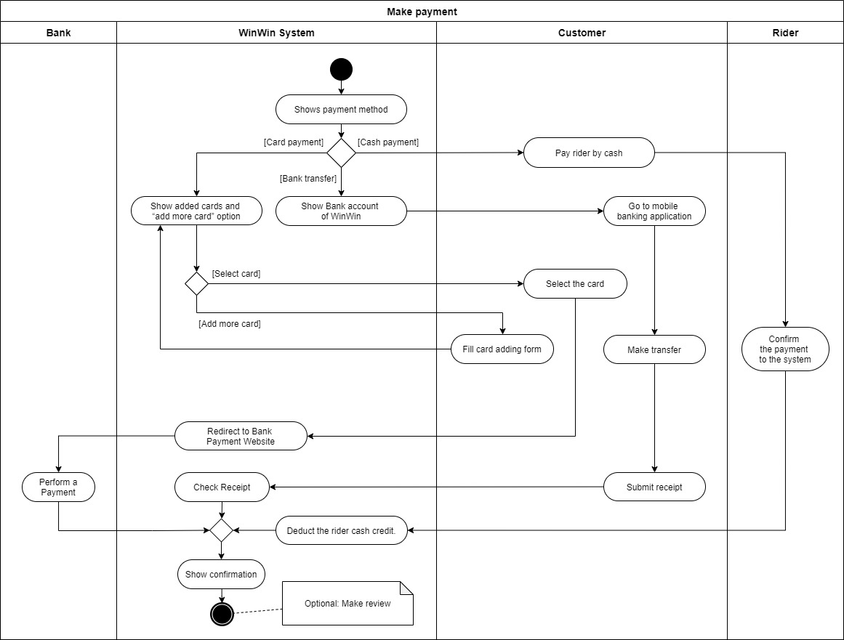

Figure 2: Activity diagram of “Make payment” Use case

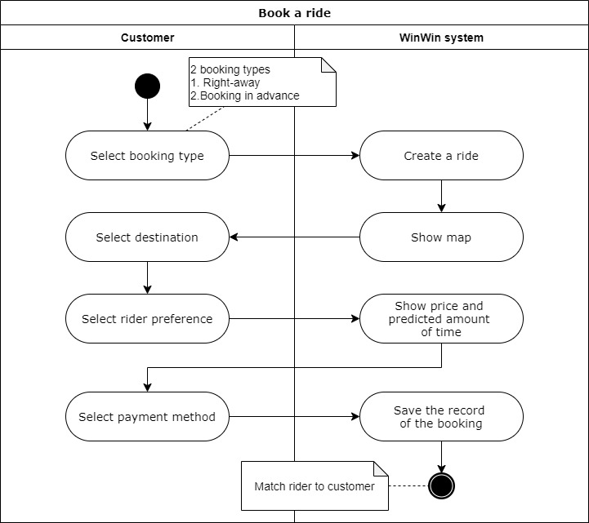

Figure 3: Activity diagram of “Book a Ride” Use case

# Detail Essential Use Case diagram and description

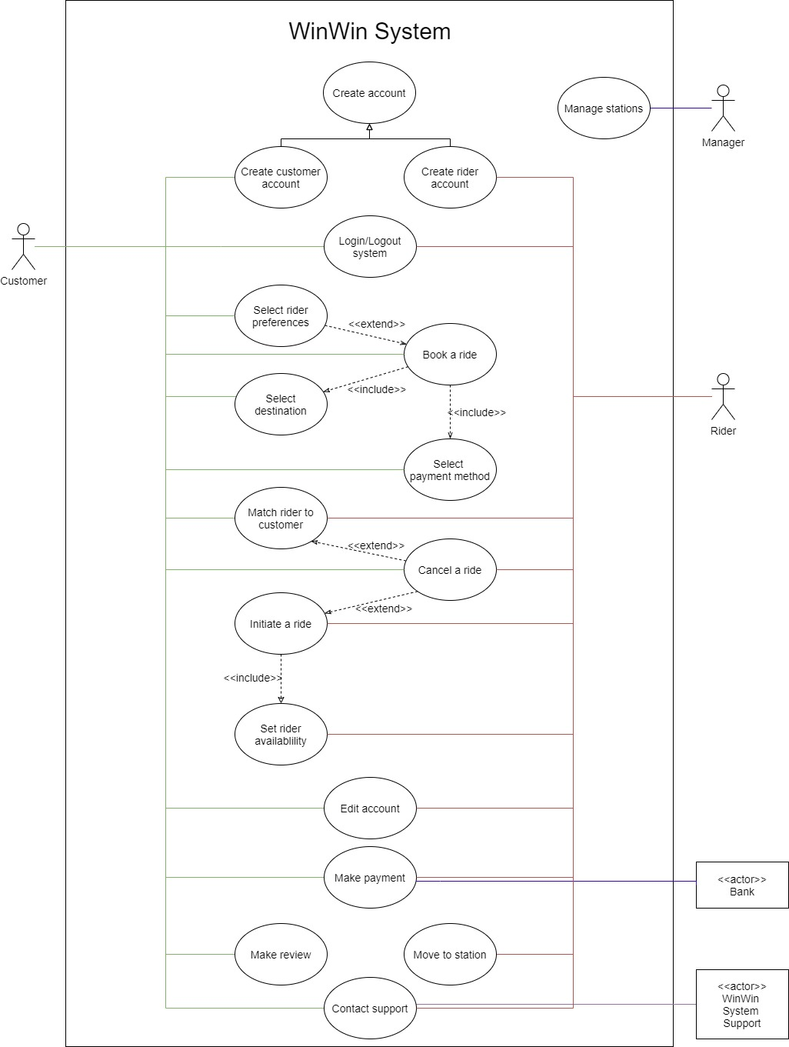

Figure 4: Use case diagram of WinWin System

**Use case explanation**

|  |  |
| --- | --- |
| Create account | This use case is a generalization of “Create customer account” and “Create rider account” use cases. |
| Create customer account | This use case describes how to create a customer account. |
| Create rider account | This use case describes how to create a rider account. |
| Login/Logout system | This use case describes how customers and riders log in or log out the system. |
| Book a ride | This use case describes how customers book a ride. |
| Select rider preferences | This use case describes how customers select rider preferences. |
| Select destination | This use case describes how customers select a destination. |
| Select payment method | This use case describes how customers select the payment method. |
| Match rider to customer | This use case describes how the system matches a rider to the customer. |
| Cancel a ride | This use case describes how customers and riders cancel rides. |
| Initiate a ride | This use case describes how riders initiate a ride. |
| Set rider availability | This use case describes how riders set their availability. |
| Edit account | This use case describes how customers and riders edit the account. |
| Make payment | This use case describes how customers make a payment. |
| Make review | This use case describes how customers make a review. |
| Contact support | This use case describes how customers and riders contact support. |
| Move to station | This use case describes how riders move to stations. |

Table 2: Use case description of “Book a ride”

|  |  |  |
| --- | --- | --- |
| **Use Case Name:** Book a ride | **ID:** 4 | **Importance Level:** High |
| **Primary Actor:** Customer | **Use Case Type:** Detail, Essential | |
| **Stakeholder and Interests:**  Customer - wants to book a ride service. | | |
| **Brief Description**: This use case describes how customers book a ride. | | |
| **Trigger**: Customer asks to book a new ride service  **Type**: External | | |
| **Relationships:**  Association:  Include:  Extend:  Generalization: | Customer  Select Payment Method, Select Destination  Select Rider Preferences  - | |
| **Precondition:** Customer logs in. | | |
| **Postcondition:** After a customer has booked a ride, the system initiates the “Match rider to customer” process. | | |
| **Normal Flow of Events:**   1. The customer selects “Booking” menu 2. The customer chooses a booking type between booking a right-away ride or booking a ride in advance. 3. The customer sets their destination for the ride.  Include flow: Select Destination 4. The customer chooses their preference for the ride.   Extension points: Select Rider Preferences 5. The system shows the price rate and predicts the amount of time of the requested ride. 6. The customer chooses their method of payment.  Include flow: Select Payment Method 7. The system saves the record of the booking. | | |
| **Subflows:** - | | |
| **Alternate/Exceptional Flow:**  1-a1: If the customer does not want to book a ride anymore at any time, the customer can select exit button to go back to home menu  2-e1: If the customer books another ride at the same riding time as another ride request, the system notifies the customer to prevent a duplication of ride request. | | |

Table 3: Use case description of “Make payment”

|  |  |  |
| --- | --- | --- |
| **Use Case Name:** Make payment | **ID: 6** | **Importance Level:** High |
| **Primary Actor:** Customer | **Use Case Type:** Detail, Essential | |
| **Stakeholder and Interests:**  Customer - wants to make a payment.  WinWin - wants to receive the fee and distribute it to riders.  Bank - wants to ensure that the transaction is legit.  Rider - wants to receive the income from the services. | | |
| **Brief Description**: This use case describes how customers make payment. | | |
| **Trigger**: Rider marks the ride as done  **Type**: External | | |
| **Relationships:**  Association:  Include:  Extend:  Generalization: | Customer, Bank, Rider  -  -  - | |
| **Precondition:**   * Customer logs in * Rider marks the ride as done | | |
| **Postcondition:** - | | |
| **Normal Flow of Events:**   1. The system shows payment screen according to the chosen payment method    1. If the customer chooses to pay in cash, The S-1: make cash payment subflow is performed    2. If the customer chooses to pay in bank transfer The S-2: make transfer payment subflow is performed    3. If the customer chooses to pay in credit card or debit card The S-3: make card payment subflow is performed 2. The system shows the confirmation of the payment and the option to review the rider | | |
| **Subflows:**  S-1: Make cash payment   1. The customer pays to the rider directly 2. The rider confirms the payment has been done 3. The system deducts the rider’s cash credit   S-2: Make bank transfer payment   1. The system shows the bank account of WinWin system 2. The customer goes to mobile banking application and make a transfer 3. The customer goes back to WinWin application 4. The customer submits the receipt to the system attachment slot 5. The system checks the submitted receipt   S-3: Make card payment   1. The system shows the added cards of the customer and “add more card” option    1. If the customer selects “add more card” option, the customer fills the card adding form 2. The customer selects the card to use as this ride payment 3. The system redirects to the bank payment website (extension system from banks) | | |
| **Alternate/Exceptional Flow:**  1-a1: If the customer wants to change payment method, the customer can select “change payment method” option to go back to payment screen (N-1)  2-e1: If the payment is failed, shows the alert, and let customer chooses the new payment method and repeat payment screen (N-1) | | |

Table 4: Use case description of “Initiate a ride”

|  |  |  |
| --- | --- | --- |
| **Use Case Name:** Initiate a ride | **ID:** 5 | **Importance Level:** High |
| **Primary Actor:** Rider | **Use Case Type:** Detail, Essential | |
| **Stakeholder and Interests:**  Customer - wants to track the rider who accepted their ride request.  Rider - wants to initiate a ride to get income. | | |
| **Brief Description**: This use case describes how riders initiate a ride. | | |
| **Trigger**: Rider accepts a ride.  **Type**: External | | |
| **Relationships:**  Association:  Include:  Extend:  Generalization: | Rider  Set rider availability  Cancel a ride  - | |
| **Precondition:**   * Rider logs in. * Rider accepts a ride. | | |
| **Postcondition:**   * After a rider marks the ride as done, the system initiates the “Make payment” process. | | |
| **Normal Flow of Events:**   1. The system makes a notification to customer about the acceptance of their ride request Include flow: Set rider availability 2. The system shows the customer the profile of the rider who accepted their ride request 3. The system shows the current location of the rider who accepted their ride request 4. The system makes a notification to the customer about the arrival of the rider who accepted their ride request | | |
| **Subflows:** - | | |
| **Alternate/Exceptional Flow:**  2-a1: If the customer or the rider wants to cancel a ride, they can select “cancel a ride” option to cancel a ride | | |

# Class diagrams and CRC Cards

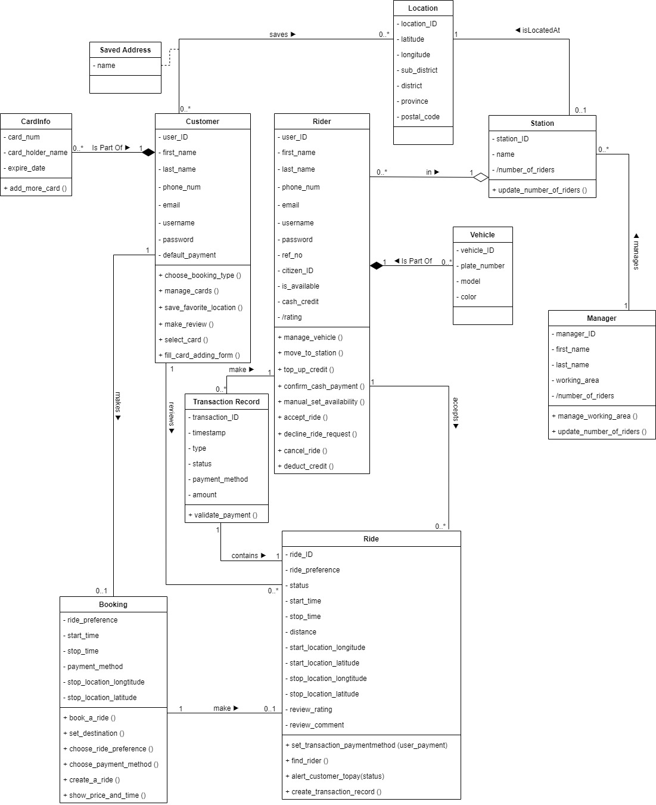

Figure 5: Class diagram of WinWin System

**Class explanation**

|  |  |
| --- | --- |
| Customer | Users who want to find a ride |
| Rider | Users who provide a ride |
| Manager | Person who takes care riders in the area |
| Booking | Booking from customer who wants a ride, use as a control object to create a ride |
| Ride | Ride from rider that is provided to customer |
| Saved Address | Customer saves their favorite locations |
| Location | Location of customer and station |
| Station | Station of a rider |
| Vehicle | Vehicle of a rider |
| CardInfo | Information of credit/debit card |
| TransactionRecord | Record of the transaction in system |

Front:

|  |  |  |
| --- | --- | --- |
| **Class name:** Customer | **ID:** 1 | **Type:** Concrete, Domain |
| **Description:**  An individual who wants to use motorcycle taxi services | **Associated Use Cases:**   * Make Payment * Book a Ride | |
| **Responsibilities**  Choose a booking type  Make review  Manage cards  Fill card adding form  Select cards  Save favorite location | **Collaborators**  Booking  Ride  CardInfo  CardInfo  CardInfo  Location | |

Back:

|  |  |
| --- | --- |
| **Attributes:**   * user_ID (char[8]) * first_name (char[50]) * last_name (char[50]) * phone_num (char[10]) | * email (char[50]) * username (char[50]) * password (char[20]) * default_payment (char[2]) |
| **Relationships:** | |
| Generalization (a-kind-of): |  |
| Aggregation (has-parts): | CardInfo |
| Other Associations: | Ride, Booking, Location, Saved Address |

Figure 6: CRC Card of Class “Customer”

Front:

|  |  |  |
| --- | --- | --- |
| **Class name:** Rider | **ID:** 2 | **Type:** Concrete, Domain |
| **Description:**  An individual who provides a ride | **Associated Use Cases:**   * Make payment | |
| **Responsibilities**  Manage vehicle  Move to station  Top up credit  Confirms reception of cash payment  Manual set availability  Accept ride  Decline ride request  Cancel ride  Deduct credit | **Collaborators**  Vehicle  Station  Transaction Record  Transaction Record  Ride  Ride  Ride | |

Back:

|  |  |
| --- | --- |
| **Attributes:**   * user_ID (char[8]) * first_name (char[50]) * last_name (char[50]) * phone_num (char[10]) * email (char[50]) * username (char[50]) | * password (char[20]) * ref_no (char[16]) * citizen_ID (char[13]) * is_available (boolean) * cash_credit (double) * rating (double) |
| **Relationships:** | |
| Generalization (a-kind-of): |  |
| Aggregation (has-parts): | Vehicle, Station |
| Other Associations: | Ride, Transaction Record |

Figure 7: CRC Card of Class “Rider”

Front:

|  |  |  |
| --- | --- | --- |
| **Class name:** Manager | **ID:** 3 | **Type:** Concrete, Domain |
| **Description:**  An individual who takes cares of the riders in working area | **Associated Use Cases:**   * Manage station | |
| **Responsibilities**  Manage working area  Update number of riders | **Collaborators**  Station | |

Back:

|  |  |
| --- | --- |
| **Attributes:**   * manager_ID (char[8]) * first_name (char[50]) * last_name (char[50]) | * working_area (char[50]) * number_of_rider (integer) |
| **Relationships:** | |
| Generalization (a-kind-of): |  |
| Aggregation (has-parts): |  |
| Other Associations: | Station |

Figure 8: CRC Card of Class “Manager”

# Sequence diagram

Figure 9: Sequence diagram of “Book a Ride” Use case

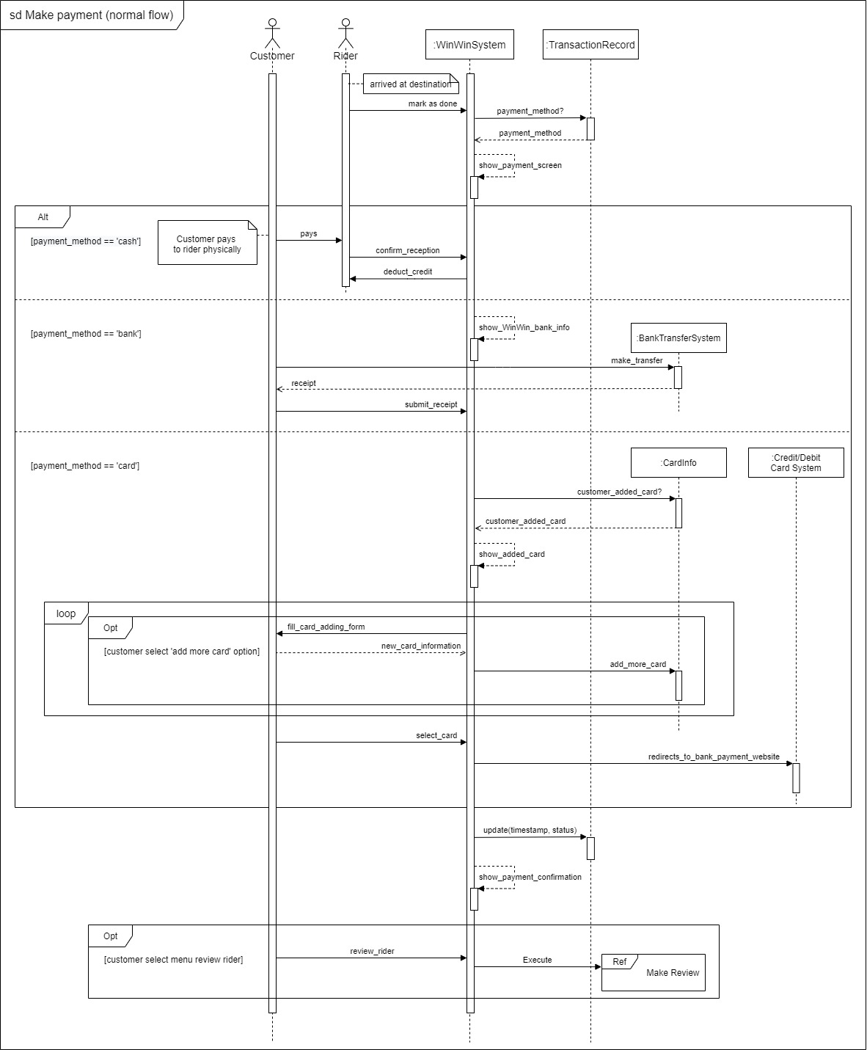

Figure 10: Sequence diagram of “Make payment” Use case

# Behavioral State Machine

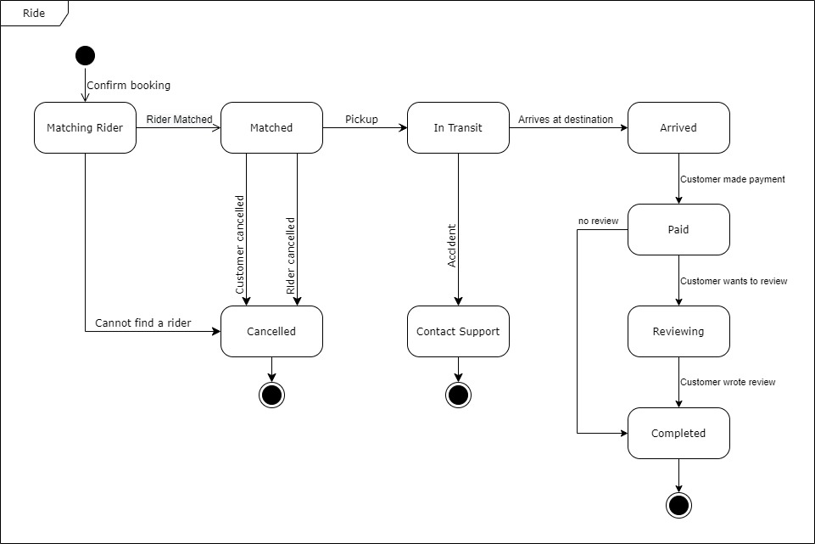

Figure 11: Behavioral state machine of Class “Ride”

# Verifying and validating the analysis model

## Verifying and validating functional model

Figure : Validating of functional model of use case “Book a ride”

Figure : Validating of functional model of use case “Make payment”

**Verifying and validating functional model**

1. For each action/activity on the activity diagram, we validated the recorded event in the flows of the use-case description. for example, the regular flow of events in “Book a ride” description corresponds to the sequence in “Book a ride” activity diagram.
2. The sequence of "Book a ride" and "Payment" corresponded to the sequence in their activity diagram.
3. There is one and only use-case description for each use-case.
4. There are actors who exist in a use-case description such as customer in “Book a ride” description, Rider and Bank in “Make payment” description which all of them are shown on the use-case diagram with association link.
5. All other relationships in the use-case description such as “select payment method” in the “Book a ride” description is depicted on the use-case diagram.

## Verifying and validating functional model

Figure : Validating of structural model of class “Rider”

Figure : Validating of structural model of class “Customer”

Figure : Validating of structural model of class “Manager”

**Verifying and validating structural model**

1. For each CRC card is associated with a class. For example, “Customer” CRC card is associated with “Customer” class on the class diagram.
2. The operations on the class diagram correspond to the responsibilities on the front of the card. For example, in the “Customer” CRC card, the “Choose a booking type” responsibility is included as an operation in the “Customer” class.
3. Collaborators on the front of the card imply some type of relationship on the back of the card as we can see from the “Customer” CRC card as “Booking” “Ride” “CardInfo” and “Location” all of which showed on the back of the card as some type of relationship.
4. On the class diagram, the attributes on the back of the card are displayed as attributes. For example, “user ID,” “email,” “first name,” and other attributes from the “Customer” CRC card are shown as attributes on the “Customer” class.
5. Relationships on the back of the card were depicted on the class diagram.

## Verifying and validating behavioral model

Figure : Validating of behavioral model of use case “Book a ride” and use case “Make payment”

**Verifying and validating behavioral model**

1. The message “confirm booking” in sequence diagram “Book a ride” is consistent with starting point of behavioral state machine of class “Ride”
2. The entire of use case “Make payment” is match with transition “Customer made payment” in behavioral state machine of class “Ride”

## Verifying and validating between models

Figure : Validating between functional model and structural model in use case “Make payment”

Figure : Validating between functional model and behavioral model of use case “Make payment”

Figure : Validating between functional model and behavioral model of use case “Book a ride”

**Verifying and validating between models**

1. Between structural model and functional model such as CRC card and Use-case description, all the actors and objects are consistent with each other, for example the “Customer” CRC card is showed as the stakeholder on the “Make payment” use-case description
2. Between functional model and behavioral model such as “Book a ride” sequence diagram and “Book a ride” use-case description, all the behaviors are referred to one scenario described in description.
3. All the actors are consistent between models. Customer and rider in the "Make payment" description, for example, are compatible with the "Make payment" sequence diagram.
4. The flows of the sequence diagrams are related to the normal flow of events in their use-case description.

# Contributions

Table : Contributions

|  |  |  |
| --- | --- | --- |
| **Name** | **Contributed part** | **Level of Achievement** |
| 6230123921  Thitaree Setwipattanachai | Proposed method of systems analysis,  Activity Diagram, CRC Card | 5 |
| 6230252121  Tarm Kalavantavanich | Use Case Diagram, Sequential Diagram,  Behavioral State Machine,  Verifying and validating the analysis model | 5 |
| 6231301421  Kanokpich Chaiyawan | Proposed method of systems analysis,  List of stakeholders, Use Case Description,  CRC Card | 5 |
| 6231304321  Kittipong Deevee | List of stakeholders, Activity Diagram,  Class Diagram | 5 |
| 6231307221  Jirawat Kusalangkurwat | Proposed method of systems analysis,  Use Case Description, CRC Card | 5 |
| 6231333521  Nopdanai Sayamnet | Objective of the analysis document,  Proposed method of systems analysis,  List of stakeholders, Class Diagram, CRC Card, Verifying and validating the analysis model | 5 |
| 6231353021  Raviporn Akekunanon | Definitions, Details of requirements,  Use Case Description, Class Diagram, Sequential Diagram,  Document correction and organization | 5 |
| 6231372021  Atiwat Deepo | Details of requirements, Activity Diagram,  CRC Card, Sequential Diagram | 5 |